- Create the LOC_TEST table with the following structure:
CREATE TABLE LOC_TEST(
location_id number(6) PRIMARY KEY,
street varchar2(40),
postal_code char(40),
city char(40),
state char(40)
)
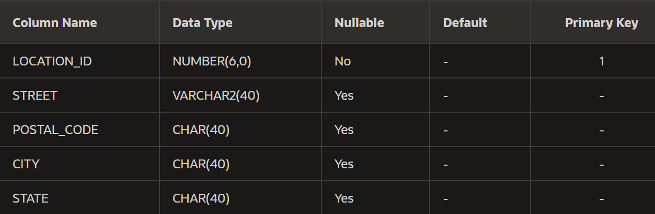
- Create the DEPT_TEST table with the following structure:

CREATE TABLE DEPT_TEST(
department_id number(6) PRIMARY KEY,
department_name char(20),
location_id number(6)
)
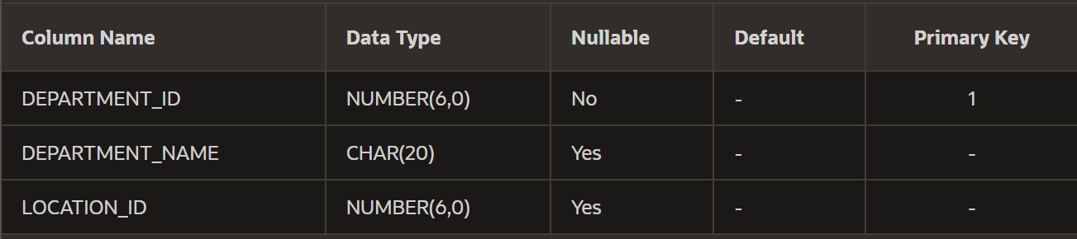

- Create the EMPL_TEST table with the following structure:

CREATE TABLE EMPL_TEST(
employee_id number(8) PRIMARY KEY,
first_name char(30),
last_name char(40),
hire_date date,
salary number(8,2),
department_id number(6)
)
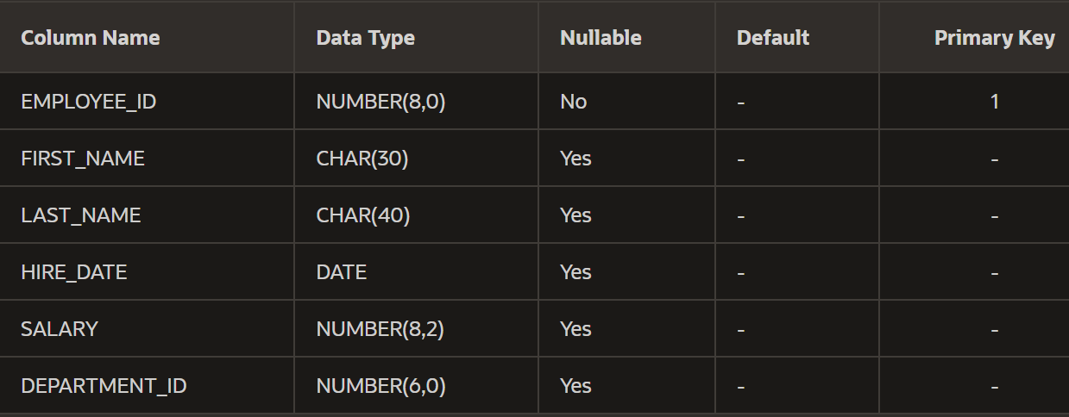
- Insert rows into the tables created based on the following tables:
LOC_TEST
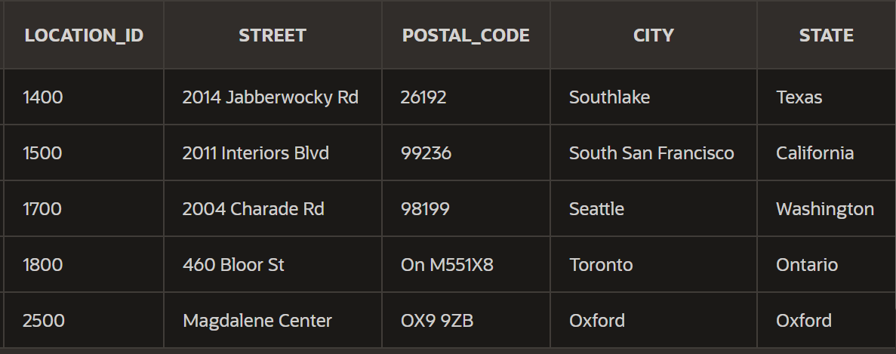
insert all into LOC_TEST
values (1400, '2014 Jabberwocky Rd', 26192, 'Southlake', 'Texas')
INTO LOC_TEST VALUES (1500, '2011 Interiors Blvd', 99236, 'South San Francisco', 'California')
INTO LOC_TEST VALUES (1700, '2004 Charade Rd', 98199, 'Seattle', 'Washington')
INTO LOC_TEST VALUES (1800, '460 Bloor St', 'On M551X8', 'Toronto', 'Ontario')
INTO LOC_TEST VALUES (2500, 'Magdalene Center', 'OX9 9ZB', 'Oxford', 'Oxford')
select 1 from dual;

DEPT_TEST
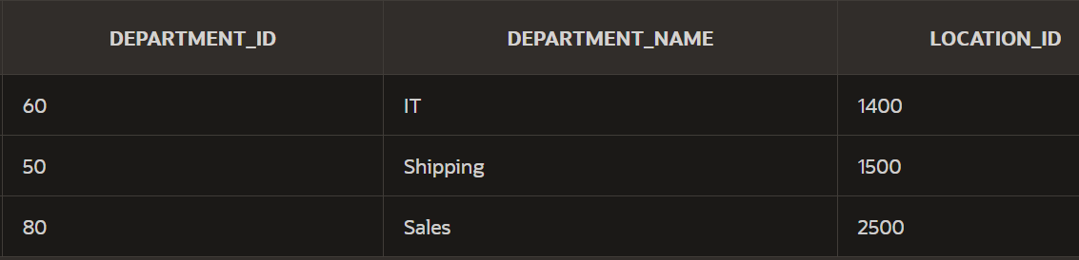
insert all into DEPT_TEST
values (60, 'IT', 1400)
INTO DEPT_TEST VALUES (50, 'Shipping', 1500)
INTO DEPT_TEST VALUES (80, 'Sales', 2500)
select 1 from dual;

EMPL_TEST
insert all into EMPL_TEST
values (141, 'Trenna', 'Rajs', '17-Oct-1995', '6945.23', 50)
INTO EMPL_TEST VALUES (143, 'Randall', 'Matos', '15-Mar-1998', '5674.68', 50)
INTO EMPL_TEST VALUES (174, 'Ellen', 'Abel', '11-May-1996', '7894.38', 80)
INTO EMPL_TEST VALUES (176, 'Jonathan', 'Taylor', '24-Mar-1998', '6784', 80)
INTO EMPL_TEST VALUES (144, 'Peter', 'Vargas', '09-Jul-1998', '4578', 50)
INTO EMPL_TEST VALUES (142, 'Curtis', 'Davies', '29-Jan-1997', '5684.9', 50)
INTO EMPL_TEST VALUES (149, 'Eleni', 'Zlotkey', '29-Jan-2000', '7956.35', 80)
INTO EMPL_TEST VALUES (124, 'Kevin', 'Mourgos', '16-Nov-1999', '6985.25', 50)
INTO EMPL_TEST VALUES (103, 'Alexander', 'Hunold', '03-Jan-1990', '8756', 60)
INTO EMPL_TEST VALUES (104, 'Bruce', 'Ernst', '21-May-1991', '6534.72', 60)
INTO EMPL_TEST VALUES (107, 'Diana', 'Lorentz', '07-Feb-1999', '5342.82', 60)
select 1 from dual;

Use EMPL_TEST, DEPT_TEST and LOC_TEST for the following:
1.
Arrange all the employees using hire_date and display the first_name, the last_name and the salary.
SELECT first_name, last_name, salary
FROM EMPL_TEST
ORDER BY hire_date;

2.
Display the minimum salary for employees having department_id=60 or 50.
SELECT MIN(salary)
FROM EMPL_TEST
WHERE department_id IN (60, 50);

3.
Display the first_name and the last_name in a single column for employees having department_id=50.
SELECT first_name ||' ' || last_name
FROM EMPL_TEST
WHERE department_id = 50;

4.
Display the first hired employee having department_id = 50.
SELECT *
FROM EMPL_TEST
WHERE hire_date = (SELECT min(hire_date) FROM EMPL_TEST WHERE department_id = 50);

5.
Increase the salary of employees having department_id=50 by 200 euros and display the salary, the last_name, the first_name and the new salary.
SELECT salary, last_name, first_name, salary+200.
FROM EMPL_TEST
WHERE department_id = 50;

6.
Display the average salary for employees where department_id = 50 or 80 and round to two decimal places.
SELECT ROUND(AVG(salary), 2)
FROM EMPL_TEST
WHERE department_id IN (50, 80);

7.
Arrange in descending order according to last_name and display first_name, last_name, salary and hire_date for employees having department_id=80 and salary >6500.
SELECT first_name, last_name, salary, hire_date
FROM EMPL_TEST
WHERE department_id=80 and salary >6500
ORDER BY last_name DESC;

8.
Increase the salary by 5% and display the first_name, the last_name, the salary, and the new salary.
SELECT first_name, last_name, salary, salary+salary*0.05
FROM EMPL_TEST;

9.
Using a substitution variable for department_id, display the maximum salary for each department.
SELECT MAX(salary)
FROM EMPL_TEST
WHERE department_id=:enter_dept_id;

10.
Display the latest hire date for department_id=80.
SELECT *
FROM EMPL_TEST
WHERE hire_date = (SELECT max(hire_date) FROM EMPL_TEST WHERE department_id = 80);

11.
Display the last in the alphabetic list of names name for department_id=50.
SELECT first_name
FROM EMPL_TEST
WHERE department_id = 50
ORDER BY first_name DESC;

12.
Display the last_name, first_name and the salary for employees havind the salary greater than the average of salaries for employees having department_id=50.
SELECT first_name, last_name, salary
FROM EMPL_TEST
WHERE salary > (SELECT AVG(salary) FROM EMPL_TEST WHERE department_id=50);

13.
Display the first_name, the last_name, and the salary for employees hired before Rajs.
SELECT first_name, last_name, salary
FROM EMPL_TEST
WHERE hire_date < (SELECT hire_date FROM EMPL_TEST WHERE last_name = 'Rajs');

14.
Display the first_name, the last_name, and the salary for employees who earn less than the average salaries for all the employees having department_id=50 or 80.
SELECT first_name, last_name, salary
FROM EMPL_TEST
WHERE salary < (SELECT AVG(salary) FROM EMPL_TEST WHERE department_id in (50, 80));

15.
Display first_name, last_name, and the salary from employees who earn more than the minimum salaries for employees hired after Vargas.
SELECT first_name, last_name, salary
FROM EMPL_TEST
WHERE salary > (SELECT min(salary) FROM EMPL_TEST WHERE hire_date <
(SELECT hire_date FROM EMPL_TEST WHERE last_name = 'Vargas'
));

16.
Display the first_name, the last_name, and the salary for employees hired before Vargas.
SELECT first_name, last_name, salary
FROM EMPL_TEST
WHERE hire_date < (SELECT hire_date FROM EMPL_TEST WHERE last_name = 'Vargas');

17.
Display the first_name, the last_name, and the salary for employees who earn less than Hunold.
SELECT first_name, last_name, salary
FROM EMPL_TEST
WHERE salary < (SELECT salary FROM EMPL_TEST WHERE last_name = 'Hunold');

18.
Display the first_name, the last_name, and the salary for employees having the same department_id as Matos.
SELECT first_name, last_name, salary
FROM EMPL_TEST
WHERE department_id = (SELECT department_id FROM EMPL_TEST WHERE last_name = 'Matos');

19.
Display all those employees who earn more than Lorentz and are in the same department as Zlotkey.
SELECT first_name, last_name, salary
FROM EMPL_TEST
WHERE salary > (SELECT salary FROM EMPL_TEST WHERE last_name = 'Lorentz') and department_id =
(SELECT department_id FROM EMPL_TEST WHERE last_name = 'Zlotkey')
;

20.
Display all those employees who have the same department_id as Rajs and were hired before Zlotkey.
SELECT *
FROM EMPL_TEST
WHERE hire_date < (SELECT hire_date FROM EMPL_TEST WHERE last_name = 'Zlotkey') and department_id =
(SELECT department_id FROM EMPL_TEST WHERE last_name = 'Rajs');

21.
Arrange all the employees having the same department as Zlotkey using salary, and display first_name, last_name and the salary.
SELECT first_name, last_name, salary
FROM EMPL_TEST
WHERE department_id = (SELECT department_id FROM EMPL_TEST WHERE last_name = 'Zlotkey');

22.
Increase the salary by 500 and display the first_name, the last_name, the salary, and the new salary for employees hired after Zlotkey.
SELECT first_name, last_name, salary, salary+500
FROM EMPL_TEST
WHERE hire_date > (SELECT hire_date FROM EMPL_TEST WHERE last_name = 'Zlotkey');

23.
Display first_name, last_name, and the salary from employees who earn more than the minimum salaries for employees havind department_id=50, 80 or 90.
SELECT first_name, last_name, salary
FROM EMPL_TEST
WHERE salary > (SELECT min(salary) FROM EMPL_TEST WHERE department_id in (50, 80, 90));

24.
Display the first_name, the last_name, and the salary for employees who earn more than the maximum salaries for all the employees having department_id=50.
SELECT first_name, last_name, salary
FROM EMPL_TEST
WHERE salary > (SELECT MAX(salary) FROM EMPL_TEST WHERE department_id = 50);

25.
Display first_name, last_name, and the salary from employees who earn more than the minimum salaries for employees hired after Matos.
SELECT first_name, last_name, salary
FROM EMPL_TEST
WHERE salary > (SELECT MIN(salary) FROM EMPL_TEST WHERE hire_date >
(SELECT hire_date FROM EMPL_TEST WHERE last_name = 'Matos'));

26.
Display the first_name, the last_name, and the salary for employees hired before Taylor.
SELECT first_name, last_name, salary
FROM EMPL_TEST
WHERE hire_date < (SELECT hire_date FROM EMPL_TEST WHERE last_name = 'Taylor');

27.
Display all the information about employees having last_name starting with „M”.
SELECT *
FROM EMPL_TEST
WHERE last_name LIKE 'M%';

28.
Display first_name with capital letter, the last_name and the salary for employees having department_id =50 or 60
SELECT UPPER(first_name), first_name, last_name, salary
FROM EMPL_TEST
WHERE department_id IN (50, 60);

29.
Display first_name, last_name, and the salary from employees who earn more than the minimum salaries for employees hired after Davies.
SELECT first_name, last_name, salary
FROM EMPL_TEST
WHERE salary > (SELECT MIN(salary) FROM EMPL_TEST WHERE hire_date >
(SELECT hire_date FROM EMPL_TEST WHERE last_name = 'Davies'));

30.
Create a join between the tables EMPL_TEST and DEPT_TEST and display all the information from both tables for employees having department_id=80.
SELECT *
FROM EMPL_TEST NATURAL JOIN DEPT_TEST
WHERE department_id=80;

31.
Display the first_name, the last_name, and the salary for employees who earns more than the maximum salaries for all the employees having department_id=60.
SELECT first_name, last_name, salary
FROM EMPL_TEST
WHERE salary > (SELECT MAX(salary) FROM EMPL_TEST WHERE department_id = 60);

32.
Display the first_name, the last_name, and the salary for employees who earns more than Rajs.
SELECT first_name, last_name, salary
FROM EMPL_TEST
WHERE salary > (SELECT salary FROM EMPL_TEST WHERE last_name = 'Rajs');

33.
Display the first_name, the last_name, and the salary for employees having department_name=IT
SELECT first_name, last_name, salary
FROM EMPL_TEST NATURAL JOIN DEPT_TEST
WHERE department_name='IT';

34.
Display the first_name, the last_name, and the salary for employees having location_id=1500.
SELECT first_name, last_name, salary
FROM EMPL_TEST NATURAL JOIN LOC_TEST
WHERE location_id=1500;

35.
Display the first_name, the last_name, the salary, the department_name and the location_id for employees having the same department_id as Rajs.
SELECT first_name, last_name, salary, department_name, location_id
FROM EMPL_TEST NATURAL JOIN DEPT_TEST
WHERE department_id = (SELECT department_id FROM EMPL_TEST WHERE last_name = 'Rajs');

36.
Display first_name, last_name, the salary, the department_name, and the location_id for employees who earn more than Mourgos.
SELECT first_name, last_name, salary, department_name, location_id
FROM EMPL_TEST NATURAL JOIN DEPT_TEST
WHERE salary > (SELECT salary FROM EMPL_TEST WHERE last_name = 'Mourgos');

37.
Create a join between EMPL_TEST and DEPT_TEST using department_id and display all the information about employees who doesn’t work in the same department as Rajs. Arrange all the employees using the last_name.
SELECT *
FROM EMPL_TEST NATURAL JOIN DEPT_TEST
WHERE department_id != (SELECT department_id FROM EMPL_TEST WHERE last_name = 'Rajs')
ORDER BY last_name;

38.
Create a join between the tables EMPL_TEST and DEPT_TEST and display all the information from both tables for employees having department_id=80 or 50.
SELECT *
FROM EMPL_TEST NATURAL JOIN DEPT_TEST
WHERE department_id IN (80, 50);

39.
Create a join between the tables LOC_TEST and DEPT_TEST using location_id and display all the information from both tables.
SELECT *
FROM LOC_TEST JOIN DEPT_TEST USING(location_id);

40.
Create a join between the tables EMPL_TEST and DEPT_TEST using department_id and display the first_name, lat_name, department_name and location_id.
SELECT first_name, last_name, department_name, location_id
FROM EMPL_TEST JOIN DEPT_TEST USING(department_id);

41.
Create a join between the tables EMPL_TEST, LOC_TEST and DEPT_TEST and display all the information for employees having department_id=80.
SELECT *
FROM EMPL_TEST NATURAL JOIN DEPT_TEST NATURAL JOIN LOC_TEST
WHERE department_id = 80;

42.
Create a join between EMPL_TEST and DEPT_TEST using department_id and display all the information about employees having department_name=IT.
SELECT *
FROM EMPL_TEST NATURAL JOIN DEPT_TEST
WHERE department_name = 'IT';

43.
Display the first_name, last_name, the street, the city and the state for employees having the same department_id as Mourgos.
SELECT first_name, last_name, street, city, state
FROM EMPL_TEST NATURAL JOIN DEPT_TEST NATURAL JOIN LOC_TEST
WHERE department_id = (SELECT department_id FROM EMPL_TEST WHERE last_name = 'Mourgos');

